Software requirements

* Javascript
* HTML
* Operating system
* Windows-7 or Windows-8

Hardware requirements

* I3-processor
* Cellron
* AMD processor

Change hardware u can add extra hardware resources

And then delete this line

## HTML

**Hypertext Markup Language** (**HTML**) is the standard [markup language](https://en.wikipedia.org/wiki/Markup_language) for creating [web pages](https://en.wikipedia.org/wiki/Web_page) and [web applications](https://en.wikipedia.org/wiki/Web_application). With [Cascading Style Sheets](https://en.wikipedia.org/wiki/Cascading_Style_Sheets) (CSS) and [JavaScript](https://en.wikipedia.org/wiki/JavaScript), it forms a triad of cornerstone technologies for the [World Wide Web](https://en.wikipedia.org/wiki/World_Wide_Web). [Web browsers](https://en.wikipedia.org/wiki/Web_browser) receive HTML documents from a [web server](https://en.wikipedia.org/wiki/Web_server) or from local storage and render them into multimedia web pages. HTML describes the structure of a web page [semantically](https://en.wikipedia.org/wiki/Semantic_Web) and originally included cues for the appearance of the document.

HTML markup consists of several key components, including those called tags (and their attributes), character-based data types, character references and entity references. HTML tags most commonly come in pairs like <h1> and </h1>, although some represent empty elements and so are unpaired, for example <img>. The first tag in such a pair is the start tag, and the second is the end tag (they are also called opening tags and closing tags).

Another important component is the HTML document type declaration, which triggers standards mode rendering.

[HTML elements](https://en.wikipedia.org/wiki/HTML_element) are the building blocks of HTML pages. With HTML constructs, [images](https://en.wikipedia.org/wiki/HTML_element#Images_and_objects) and other objects, such as [interactive forms,](https://en.wikipedia.org/wiki/Fieldset) may be embedded into the rendered page. It provides a means to create [structured documents](https://en.wikipedia.org/wiki/Structured_document) by denoting structural [semantics](https://en.wikipedia.org/wiki/Semantics) for text such as headings, paragraphs, lists, [links](https://en.wikipedia.org/wiki/Hyperlink), quotes and other items. HTML elements are delineated by *tags*, written using [angle brackets](https://en.wikipedia.org/wiki/Bracket#Angle_brackets). Tags such as <img> and <input> introduce content into the page directly. Others such as <p> and </p> surround and provide information about document text and may include other tags as sub-elements. Browsers do not display the HTML tags, but use them to interpret the content of the page. HTML can embed programs written in a [scripting language](https://en.wikipedia.org/wiki/Scripting_language) such as [Java Script](https://en.wikipedia.org/wiki/JavaScript) which affect the behavior and content of web pages. Inclusion of CSS defines the look and layout of content. The [World Wide Web Consortium](https://en.wikipedia.org/wiki/World_Wide_Web_Consortium) (W3C), maintainer of both the HTML and the CSS standards, has encouraged the use of CSS over explicit presentational HTML since 1997.

It is very powerful and supports a variety of features, including:

1. **Text**and all places where it is used, i.e. paragraphs, headings, quotes, etc.
2. **Multimedia:**images, audio, and video,
3. The so-called **canvas,**which allows you to "draw" on the Web page using JavaScript code.
4. Traditionally, HTML is learned along with **CSS**and **Java Script,**in what we call the web development trio. Together, they make the foundation behind the Internet as we see it today.

There are some "spinoffs" of HTML, which are used in different circumstances as well:

1. **DHTML**- Dynamic Hyper Text Markup Language, same as normal HTML but more flexible,
2. **XML**- Extensible Markup Language, used for documentation and creating layout files during Android development.

**Advantages of html:**

Most people in the web design and development industry; whether a freelancer or an agency, are familiar with HTML. If your site is made using HTML and you need to take the help of a new designer to update or modify anything on it, it will be much easier to find a designer who is familiar with the language and can make the changes to it for an affordable fee.

HTML is supported by almost all the browsers that are available today. In fact, it is supported by more browsers than any other programming language. As a result, your website will open on almost all the browsers around the world if it is created using HTML. Also, is it is easy to optimize a website that is made using HTML.

XML is a common platform that is used these days for storing data. The syntax of HTML is very similar to that of XML. Hence, it will be very easy and hassle free to work between these two platforms if your site is designed in HTML.

One big advantage of HTML is that it does not cost anything. It is free of cost. Since it does not need any plug-ins or software’s, you will save a lot of money if you choose to design your site using this language.

HTML can be used with many web development tools like FrontPage or Dream Weaver. It is supported by almost all of the development tools and hence it will be much easier to create and develop a website using HTML in comparison to other programming languages.

Out of all the programming languages that are available in the industry today, HTML is the most search engine friendly language. It is very easy to create a website using HTML. It causes minimal problems in terms of SEO and is very easy to work with when you try to make changes to your site to make it SEO compliant. As long as the code used to create your site is clean, a site made using HTML will be the easiest for web crawlers to read and crawl. As a result the time taken to crawl the website will be reduced and the page load time of your site will also be significantly less.

Though HTML has a lot of advantages, it is important for you to stop and think about what the main function of your website is going to be before proceeding to design it. Some of the questions that you need to ask yourself are if you want a site that just gives information about the work you do or will you need an ecommerce site? Is your site going to be a marketing platform for your business or will it be a site where content like news is added every few hours? Do you want it to be a platform where people get information or do you want to make it interactive?

The most important thing that you need to think about is what your site needs. Many times, if yours is a growing business, all you may need is a simple site without all the complicated and advanced technologies. An HTML web design will make your site look as visually appealing to your visitors as a site made using other advanced technologies. Many times you can get carried away with all the fancy technologies available in the industry. But it is important for you to take a decision based on what is necessary for your business and how you can save unnecessary costs involved in web design and development.

We have been at the forefront of custom website development for over twenty years. We started designing websites when HTML was the ONLY option available. Even with the advent of content management systems, our capability of building contemporary HTML based websites has only grown. If you need a website designed and need to know whether a CMS or HTML based website is best for you, write to us today!

JAVASCRIPT

JAVASCRIPT was initially created to “make web pages alive”. The programs in this language are called scripts. They can be written in the HTML and execute automatically as the page loads. Scripts are provided and executed as explain text. They don’t need a special proportion or a compilation to run.

When Java script was created it initially had another name “LIVESCRIPT “. Java script became a fully independent language , with its own specification called “ECMA SCRIPT”. Actually on any device where there exists a special program called the “JAVA SCRIPT ENGINE”. The browser has an embedded engine, sometimes it also called a “JAVASCRIPT VIRTUAL MACHINE”. Different engines have different “CODENAMES”. For examples

* V8-in chrome and opera
* Spider-monkey-in fire-fox

CSS

**Cascading Style Sheets** **(CSS**) is a [style sheet language](https://en.wikipedia.org/wiki/Style_sheet_language) used for describing the [presentation](https://en.wikipedia.org/wiki/Presentation_semantics) of a document written in a [markup language](https://en.wikipedia.org/wiki/Markup_language). Although most often used to set the visual style of [web pages](https://en.wikipedia.org/wiki/Web_page) and user interfaces written in [HTML](https://en.wikipedia.org/wiki/HTML) and [XHTML](https://en.wikipedia.org/wiki/XHTML), the language can be applied to any [XML](https://en.wikipedia.org/wiki/XML) document, including [plain XML](https://en.wikipedia.org/wiki/Plain_Old_XML), [SVG](https://en.wikipedia.org/wiki/Scalable_Vector_Graphics) and [XUL](https://en.wikipedia.org/wiki/XUL), and is applicable to rendering in [speech](https://en.wikipedia.org/wiki/Speech_synthesis), or on other media. Along with HTML and [JavaScript](https://en.wikipedia.org/wiki/JavaScript), CSS is a cornerstone technology used by most websites to create visually engaging web pages, user interfaces for [web applications](https://en.wikipedia.org/wiki/Web_applications), and user interfaces for many mobile applications.

CSS is designed primarily to enable the separation of presentation and content, including aspects such as the [layout](https://en.wikipedia.org/wiki/Page_layout), [colors](https://en.wikipedia.org/wiki/Color), and [fonts](https://en.wikipedia.org/wiki/Typeface). This separation can improve content [accessibility](https://en.wikipedia.org/wiki/Accessibility), provide more flexibility and control in the specification of presentation characteristics, enable multiple HTML pages to share formatting by specifying the relevant CSS in a separate .css file, and reduce complexity and repetition in the structural content.

Separation of formatting and content makes it possible to present the same markup page in different styles for different rendering methods, such as on-screen, in print, by voice (via speech-based browser or [screen reader](https://en.wikipedia.org/wiki/Screen_reader)), and on [Braille-based](https://en.wikipedia.org/wiki/Braille_display) tactile devices. It can also display the web page differently depending on the screen size or viewing device. Readers can also specify a different style sheet, such as a CSS file stored on their own computer, to override the one the author specified.

Changes to the [graphic design](https://en.wikipedia.org/wiki/Graphic_design) of a document (or hundreds of documents) can be applied quickly and easily, by editing a few lines in the CSS file they use, rather than by changing markup in the documents.

The CSS specification describes a priority scheme to determine which style rules apply if more than one rule matches against a particular element. In this so-called cascade, priorities (or weights) are calculated and assigned to rules, so that the results are predictable.

The CSS specifications are maintained by the [World Wide Web Consortium](https://en.wikipedia.org/wiki/World_Wide_Web_Consortium) (W3C). Internet media type ([MIME type](https://en.wikipedia.org/wiki/MIME_media_type)) text/css is registered for use with CSS by [RFC 2318](https://tools.ietf.org/html/rfc2318) (March 1998). The W3C operates a free [CSS validation service](https://en.wikipedia.org/wiki/W3C_Markup_Validation_Service#CSS_validation) for CSS documents.

**Approaches to use of CSS :**

There are a number of ways in which CSS can be deployed:

**External CSS Files :**

The best way to use CSS is to store the CSS data in an external file and link to this file using the <link> HTML element. This approach allows the CSS definitions to be used by every page on your Web site.

**Internal CSS :**

You can store CSS within a HTML by including it using the <style> element within the <head> section at the top of your HTML file. However this approach means the style definitions cannot be applied to other files. This approach is not normally recommended.

**Inline CSS :**

You can embed your CSS inline with HTML elements: for example <p style="font-color: red" > uses CSS to specify that text in the current paragraph is red. However this approach means that the style definitions cannot be applied to other paragraphs. This approach is discouraged.

## Advantages of Using CSS :

The biggest advantage of CSS is that it allows separating content of an html document from the style and layout of that document. It can thus make documents much easier to maintain and give much better control over the layout of your web pages, because content of an entire set of HTML pages can be easily controlled using one or more style sheets.

Here are some more advantages, why one should opt for designing website using CSS?

**CSS Save lots of time** — CSS gives lots of flexibility to set the properties of an element. You can write CSS once; and then the same code can be applied to the groups of HTML elements, and can also be reused in multiple HTML pages.

**Easy maintenance** — CSS provide an easy means to update document formatting and maintain consistency across multiple documents. By making one change to the website's CSS, elements in all the web pages will be updated automatically.

**Pages load faster** — CSS enable multiple pages to share formatting, and reduce complexity and repetition in the structural content. It significantly reduces the file transfer size, which results in a faster page loading.

**Superior styles to HTML** — CSS has much wider presentation capabilities than HTML, so you can give far better look to your HTML pages in comparison to the HTML presentational elements and attributes.

**Multiple Device Compatibility** — CSS can also allow the HTML document to be optimized for more than one type of device or media. Using CSS the same HTML document can be presented in different viewing styles for different rendering devices such as computer screen, cell phones, printer, etc.

PROGRAM CODE

OUTPUT SCREENSHOTS

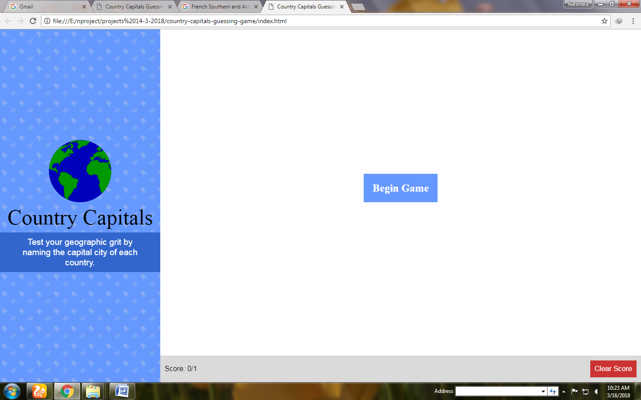

CONCLUSION